1. Introduction

1.1 Purpose
- Matzilon is a self-care utility app that aims to improve the mental stability, and provide a basic self-care to people with mental health issues.
- This document will describe the current notification system that Matzilon implements.

1.2 Scope
- The notifications are currently local in nature, as this is the first version of the feature and its most bare-bones version. Details on how to expand the system will be described in.

1.3 Overview
- The user is able to decide on what time to schedule his notification/s.
- In future implementation, maybe let the user pick what his notification should look like (either from a list of options or complete customization)

2. System Overview

2.1 Background
- In order to implement local notifications the package flutter_local_notifications was used.
- Currently the package supports both ios, android and web.
- We setup the system only for android. For further instructions on how to setup android and app look here.

3. Requirements

3.1 Functional Requirements
- משפט עידוד משתנה כל יום
מסך הגדרות -
בחירת השעה של ההודעה
אפשרות לבטל שליחת הודעות
לוקחים משפטים מ
inspirational quotes
- The user needs to allow us to use the USE_EXACT_ALARM and RECEIVE_BOOT_COMPLETED permissions.
- Those requirements weren’t implemented.
In order to fully implement this we need to move from local notification to push notifications.
Which in turn requires:
1. An external server to manage and send the notification.
2. A way to uniquely identify each user.
Without those 2 features the only possible implementation is a static massage.

3.2 Non-Functional Requirements
- The current local notifications do not require any additional, external requirements. But in order to fully implement the suggested system an authentication system needs to be implemented.

4. Design Considerations

4.1 Assumptions
- The user might want to schedule multiple notifications
- Editing the time is less important, as removing and adding a new one does the same thing.
- The user needs to know, and be able to cancel any and all upcoming notification

4.2 Constraints
- It’s not possible to send changing, truly dynamic, local notifications.
- We do not have an authentication system yet
- There is no external server to handle push notifications.

4.3 Design Principles
- The notification system is orthogonal to the app, and it’s implementation can be changed at any point with the minimal effort possible
- The notification screen was added to the sub menu where the other “extra features” are, as this is a more suiting place for it.

5. System Architecture

5.1 High-Level Architecture Diagram
- Include diagrams showing system components and interactions.

5.2 Components Description
The menu now has a notification page.
The notification page has a time-picking area, in where the user picks the time for the notification.
It also has a Notification List which is a list of Notification List Items, detailing the scheduled notifications and allowing the user to cancel them.
The notification service itself is implemented in notification_service and is called NotificationHelper

6. Detailed Design

6.1 Module Overview

6.1.1 notification_service
- Purpose: implements the notification system, using the package flutter_local_notifications.
- Functionality: let’s the user add and remove a notification(currently only on android)
- Interfaces: NotificationHelper.init() initializes the notification service
NotificationHelper.scheduleNotification( TimeOfDay time, String id) schedules a notification with the identifier id at the time time
NotificationHelper.cancelNotification(String id) cancels the notification with the given id
NotificationHelper.cancelNotifications() resets the system and cancels all notifications.

6.1.1 notification_list_item
- Purpose: create each notification widget to display to the user.
- Functionality: shows a notification and allow the user to delete it.

6.1.1 notification_list
- Purpose: show to the user the list of all current notifications.
- Functionality: displays the list of notifications

6.1.1 notification_page
- Purpose: creates the interface for the user to manage his notifications
- Functionality: lets the user pick at which time to schedule a notification and manage his notifications.

8. User Interface Design
Here is the 0.1 UI version
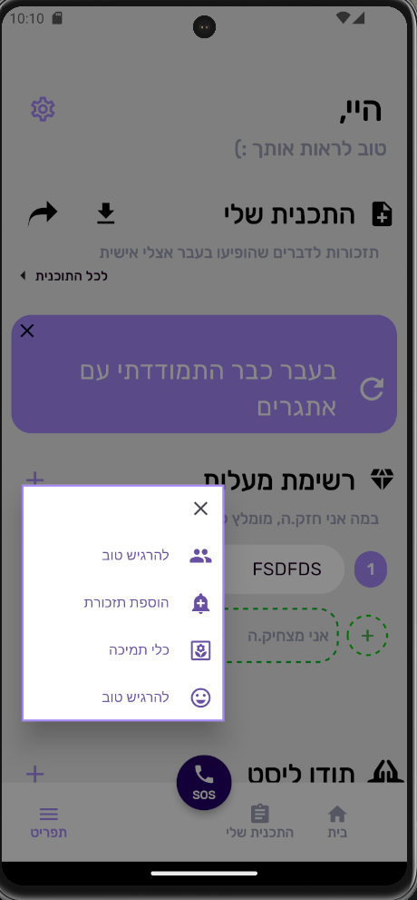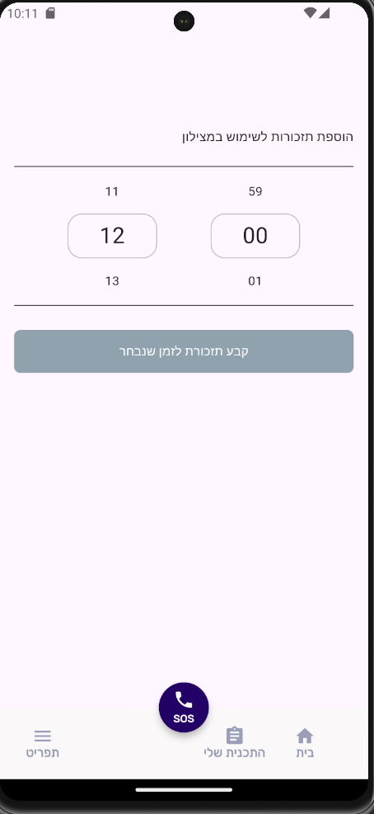
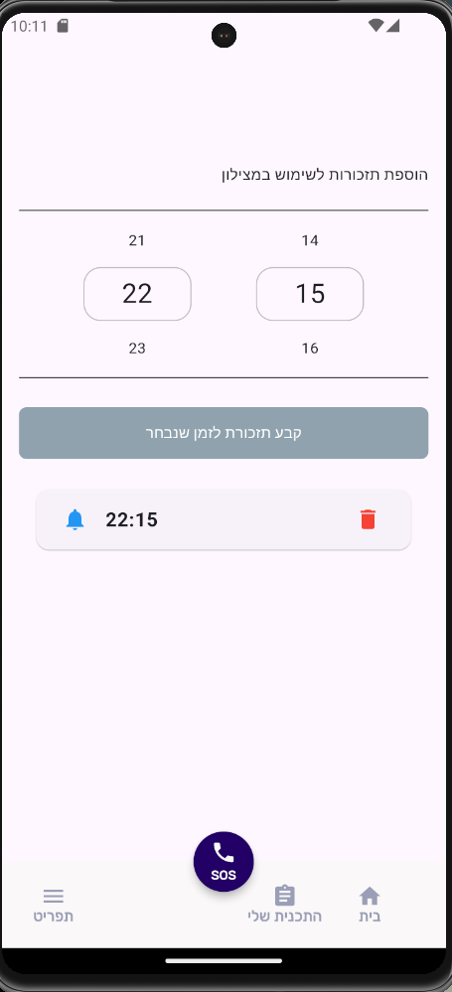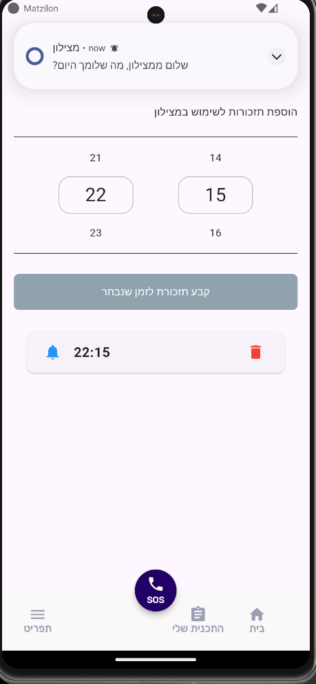

9. External Interfaces

9.2 Software Interfaces
- For flutter_local_notifications:
- FlutterLocalNotificationsPlugin() creates the api that lets us interact with the package
- FlutterLocalNotificationsPlugin.Initialize() lets us setup and start the notification system for all systems
- InitializationSettings() lets us customize the notification’s visual component
- FlutterLocalNotificationsPlugin.zonedScheduled() schedules a repeating notification based on the parameters given to it
For more details look here.

10. Security Considerations

10.1 Authentication
- Like described before, for the full implementation of the desired system an authentication system needs to be implemented.

